Part 6 Reinforcement Learning

Table of Contents

The Multi-Armed Bandit Problem 1

Lottery machines 1

Upper Confident Bound (UCB) 3

The Algorithm 3

Thompson Sampling Intuition 6

UCB VS Thompson sampling algorithm 8

# The Multi-Armed Bandit Problem

## Lottery machines

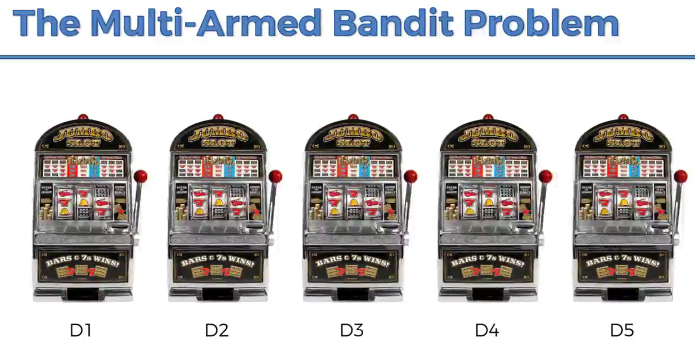

The machine on the right is the optimal machine fit with that problem

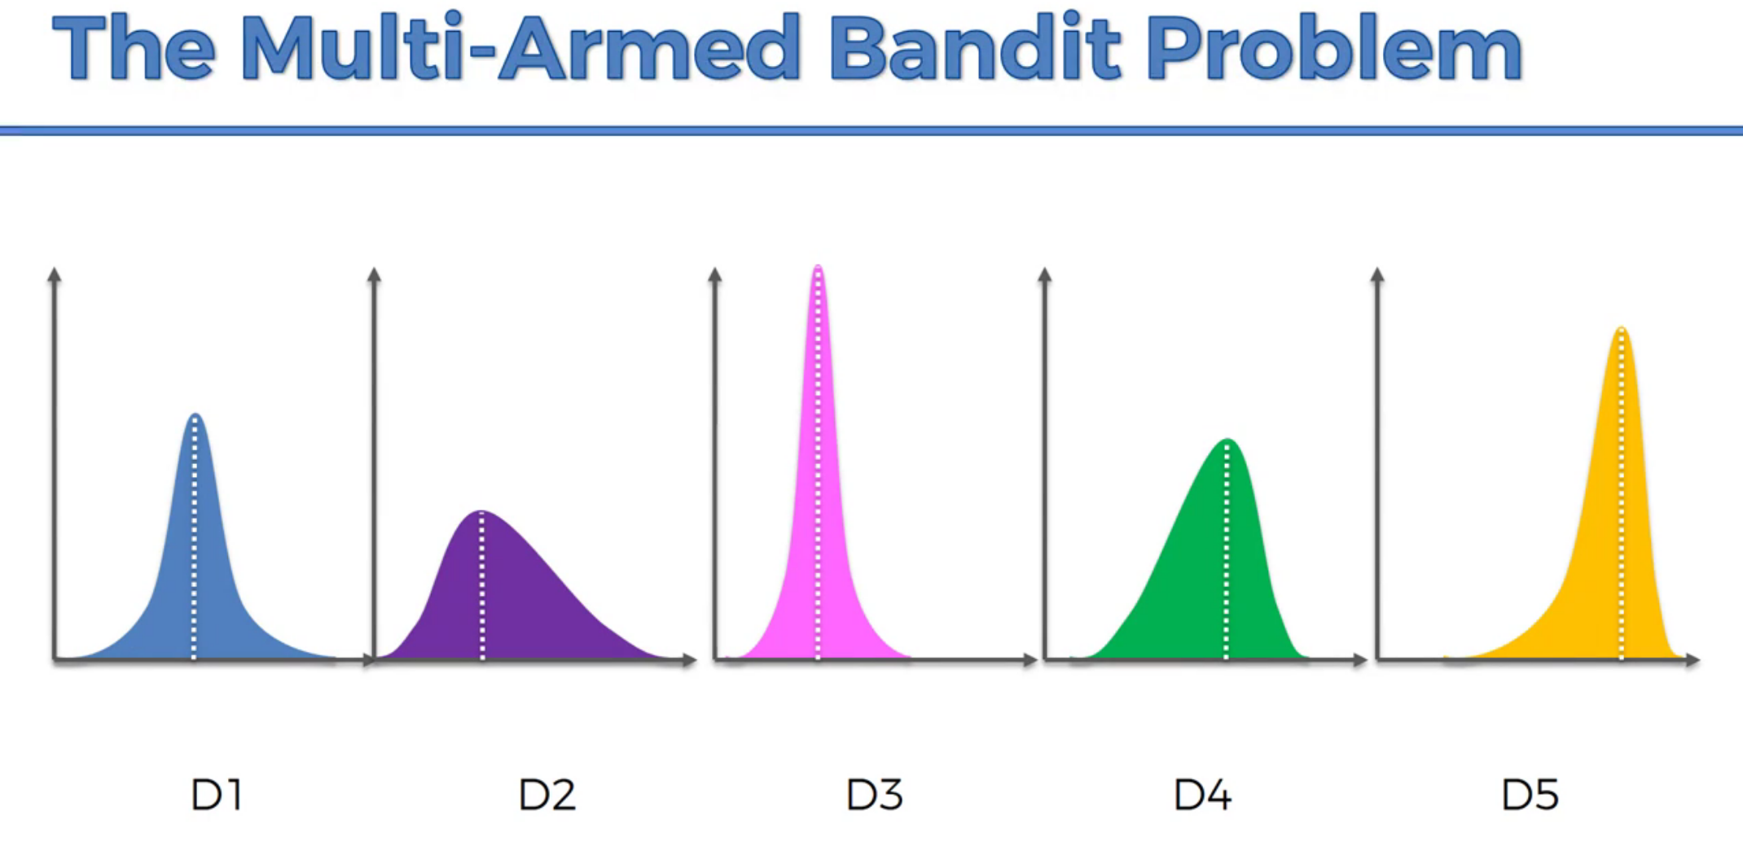

Sample of problems: This is Ad campaign for Coca-cola, which is the best Ad Campaign?

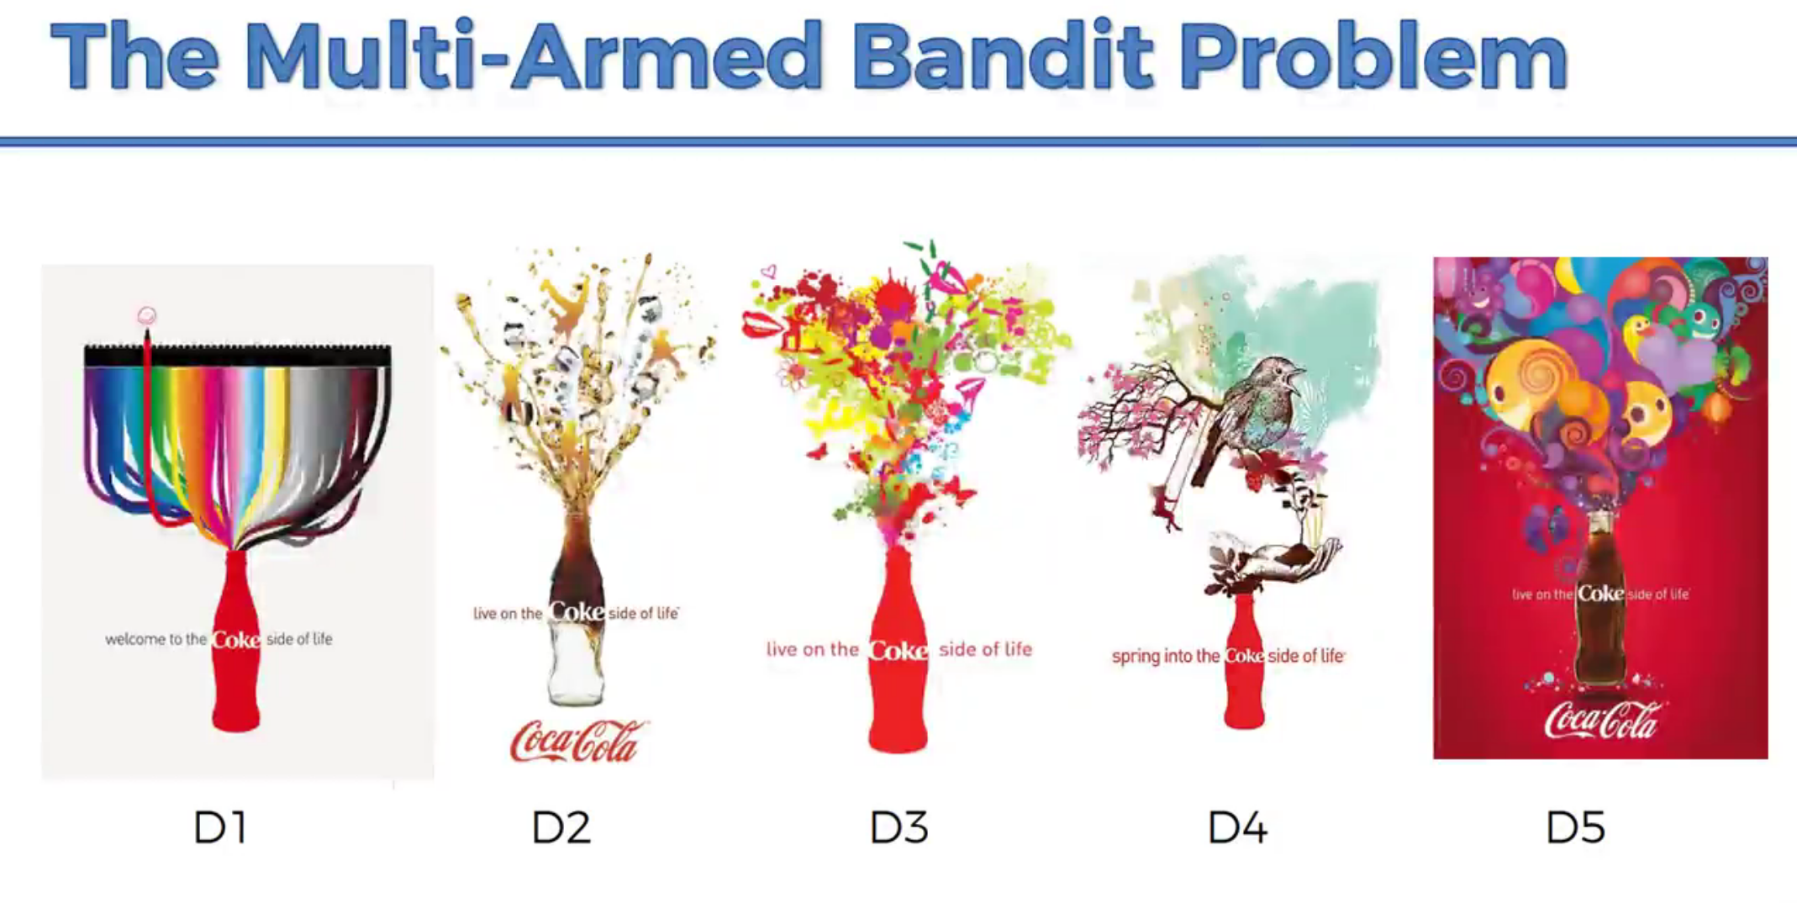

# Upper Confident Bound (UCB)

## The Algorithm

It’s more Robot and AI algorithm, that we can start with no data.

## 

* 1. Ad Expected return levels

# 

* 1. Updating the confident level by time with the observations seen in the new data received

1. 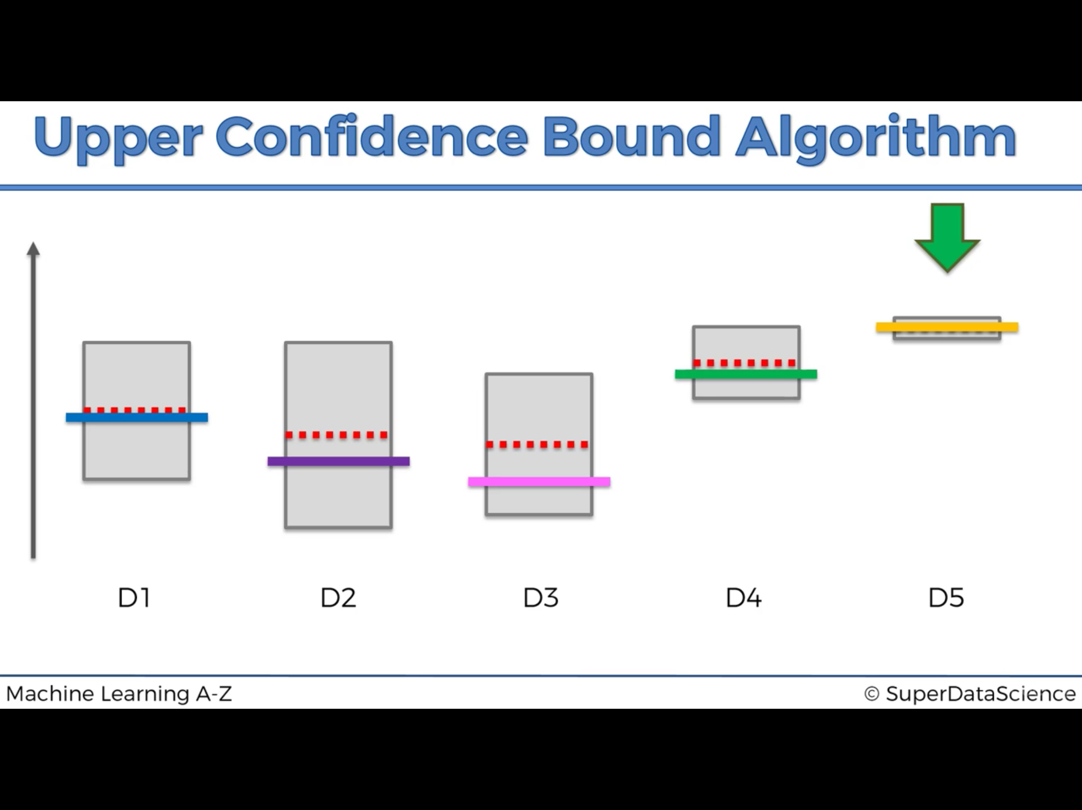

# Thompson Sampling Intuition

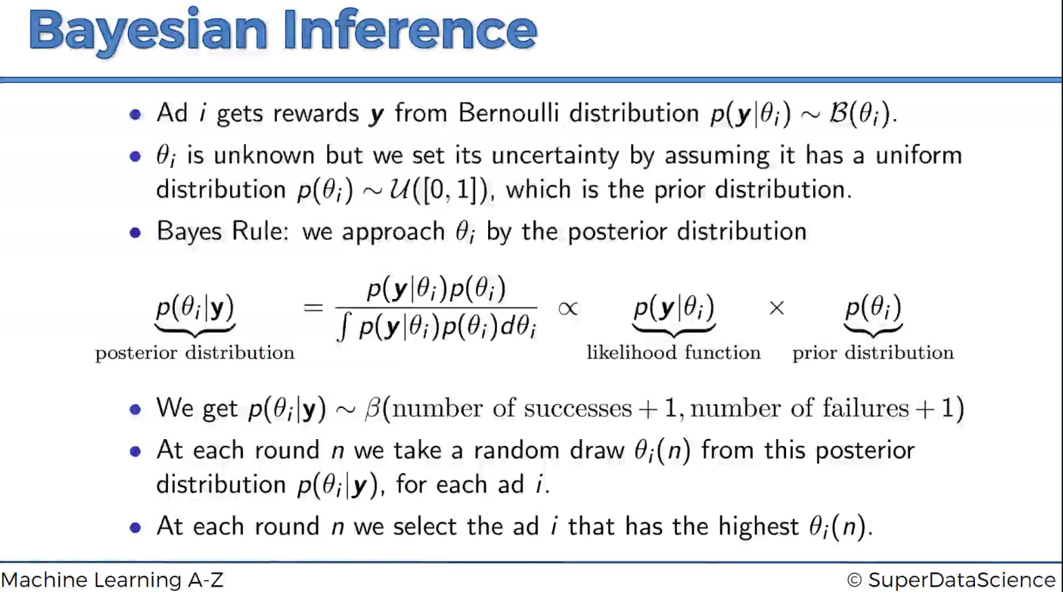

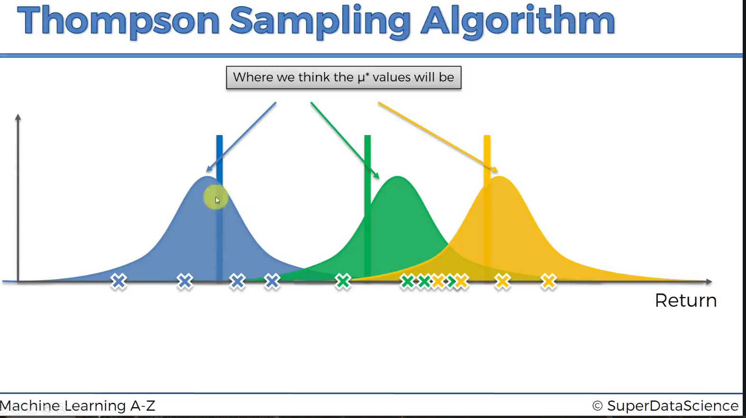

Adjust the perception after each round.

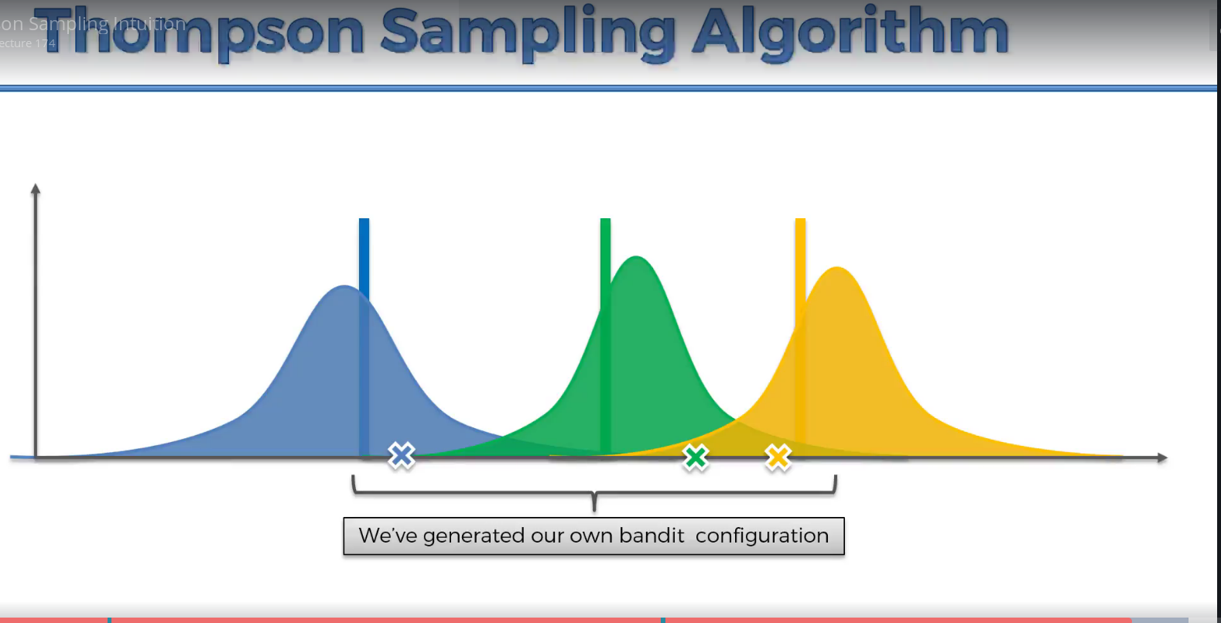

# UCB VS Thompson sampling algorithm

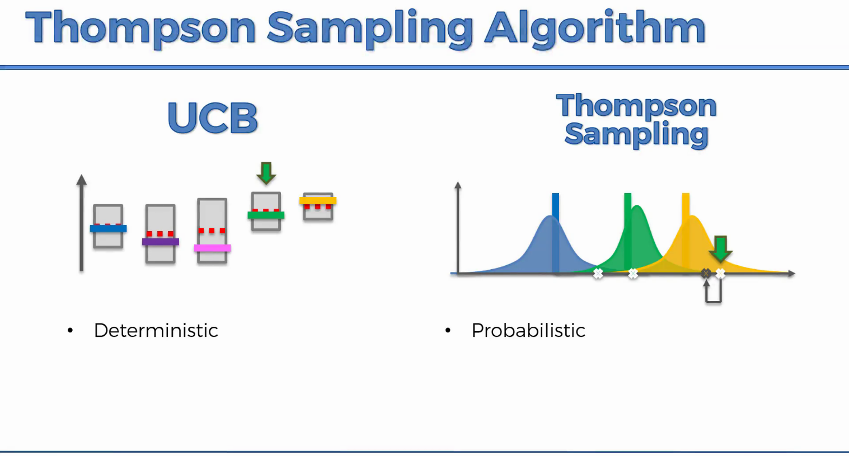

Thompson sampling algorithm is working better in real world.

